

2006

Term 1 Examination

HSC CHEMISTRY

General Instructions  - Reading time - 5 minutes  - Working time - 2 hours  - Write using black or blue pen  - Draw diagrams using pencil  - Board approved calculators may be used  - A data sheet and periodic table are provided at the back of this paper  - Write your student number at the top of every page. | Total marks - 65  This exam has two parts, Part A and Part B  Section I – 53 marks  Part A (10 marks)  - Attempt Questions 1-10  - Allow about 20 minutes for this section  Part B (43 marks)  - Attempt Questions 11- 18  - Allow about 70 minutes  Section II - 12 marks  Option  - Attempt Question 19  - Allow about 30 minutes for this section

Blank Page

Section 1
53 marks

Part A

Total marks 10
Attempt questions 1-10
Allow about 20 minutes for this part.

Use the Multiple-choice Answer Sheet provided.

Answer the questions by selecting the alternative that best answers the question. Indicate your choice by filling in the appropriate place on the Answer sheet, as shown below, where A has been selected as the best alternative,
A
B
C
D

If you make a mistake, indicate your choice by labelling the correct alternative, as shown below where, the original choice A was a mistake, and C is now selected as being the correct answer.
Correct
A
B
C
D
X

1. | Which of the following pairs would form a buffer solution?  - HCl_{(aq)} / Cl⁻_{(aq)}  - H₂PO₄⁻_{(aq)} / PO₄³⁻_{(aq)}  - H₂SO_{4 (aq)} / HSO₄⁻ _{(aq)}  - CH₃COOH_{(aq)} / CH₃COO⁻_{(aq)}
2. | The figure shows the pH values of some substances.  pH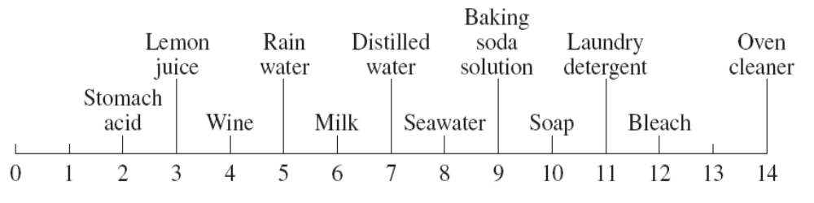  Based on the pH values shown in the figure, in which of the following is the concentration of hydrogen ions correct?  - It is twice as great in milk as that in lemon juice  - It is 1 000 000 times greater in soap than in wine  - It is three times greater in wine than in bleach solution  - It is 1 000 times greater in distilled water than in soap
3. | The table shows the colours of three indicators at different hydrogen ion concentrations.  What is the pH of a solution that showed the following indicator colours?  - 2  - 4  - 6  - 8
  [HCl] molL⁻¹ | 10⁻² | 10⁻⁴ | 10⁻⁶
  Methyl Orange | red | orange | yellow
  Bromothymol Blue | yellow | yellow | green
  Phenol Red | yellow | red | red
  Methyl Orange | Yellow
  Bromothymol Blue | Green
  Phenol Red | Red

4 | One mole of which of the following acids will require three moles of sodium hydroxide to achieve complete neutralisation?  - hydrochloric acid  - citric acid  - sulphuric acid  - ethanoic acid
5 | The following equilibria occur in a bottle of carbonated soft drink:  CO_{2(g)}  CO_{2 (aq)} + energy  CO_{2 (aq)} + H₂O_{(l)}  H₂CO_{3(aq)}  H₂CO_{3(aq)} + 2 H₂O_{(l)}  2 H₃O⁺_{(aq)} + CO₃²⁻_{(aq)}  Which one of the following will favour the release of carbon dioxide from the soft drink?  - putting a lid on the bottle  - decreasing the temperature of the soft drink  - increasing the pH of the soft drink  - adding a small amount of vinegar to the soft drink
6 | 10 mL of a 0.05 molL⁻¹ solution of sulphuric acid was diluted by making up to 1000 mL with distilled water. What was the pH of the resulting solution?  - 3.0  - 2.0  - 4.0  - 3.3

7 | A student performed a titration with a strong base and an acid. He used computer based technology and the following graph was produced.  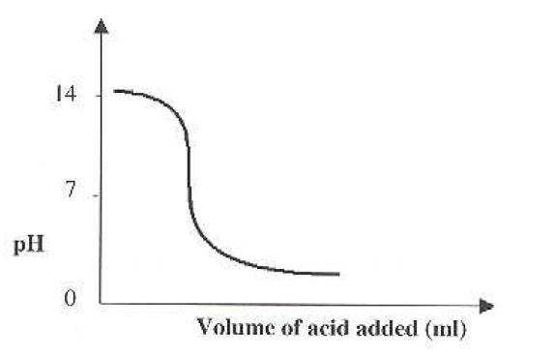  From the information in the graph it can be deduced that:  - the acid was a weak acid and the end point was at pH 8  - the acid was a strong acid and the end point was at pH 8  - the acid was a weak acid and the end point was at pH 2.5  - the acid was a strong acid and the end point was at pH 11
8 | Which of the following correctly identifies the amphiprotic species with both its conjugate acid and its conjugate base?
   | Conjugate acid | Amphiprotic species | Conjugate base
  (A) | HCO₃⁻ | H₂CO₃ | CO₃²⁻
  (B) | NH₄⁺ | NH₃ | NH₂⁻
  (C) | OH⁻ | H₂O | H₃O⁺
  (D) | H₂SO₄ | SO₄²⁻ | HSO₄⁻

9 | It is known that gases A and B reach equilibrium as they react together to form gas C. The variation in concentration of these gases was monitored and graphed as illustrated below.  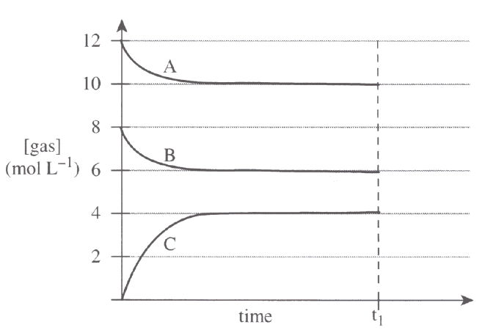  By applying Le Chatelier’s Principle, it can be predicted that at time t₁ the yield of the forward reaction will  - increase if pressure is increased.  - decrease if pressure is increased.  - decrease if pressure is decreased.  - not be affected by a change in pressure.
10 | In which one of the following beakers will a displacement reaction occur?  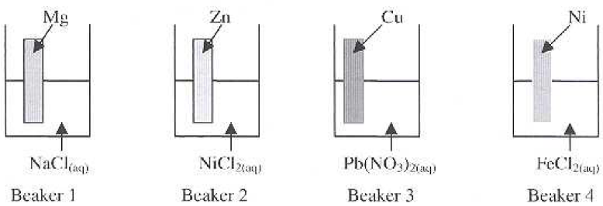  - Beaker 1  - Beaker 2  - Beaker 3  - Beaker 4

Section 1 (continued)

Part B – 43 marks
Attempt Questions 11-19
Allow about 1 hour and 10 minutes for this part

Answer the questions in the spaces provided.

Show all relevant working in questions involving calculations.

Question 11 (5 marks)  During your practical work, you have performed a first-hand investigation to prepare and test a natural acid/base indicator.  - Describe the procedure you used to test this indicator and explain how this indicator can distinguish between an acid and a base.  ………………………………………………………………………………………....................  ………………………………………………………………………………………....................  ………………………………………………………………………………………....................  ………………………………………………………………………………………....................  ………………………………………………………………………………………....................  ………………………………………………………………………………………....................  ………………………………………………………………………………………....................  ………………………………………………………………………………………....................  ………………………………………………………………………………………....................  ………………………………………………………………………………………....................  - Identify an everyday situation in which an indicator is used and explain why it is necessary to use the indicator.  ………………………………………………………………………………………....................  ………………………………………………………………………………………....................  ……………………………………………………………………………………….................... | 3  2

Question 12 (4 marks)  Vinegar is an aqueous solution of acetic (ethanoic) acid, a weak acid.  - Apart from its taste, explain why acids such as vinegar are often used as food additives.  ………………………………………………………………………………………....................  ………………………………………………………………………………………....................  ………………………………………………………………………………………....................  ………………………………………………………………………………………....................  - Explain why such a solution would have a higher pH than hydrochloric acid solution of the same concentration.  ………………………………………………………………………………………....................  ………………………………………………………………………………………....................  ………………………………………………………………………………………....................  ……………………………………………………………………………………….................... | 2  2

Question 13 (6 marks)  Different theories of acids and bases were developed by Lavoisier, Davy, Arrhenius and Bronsted-Lowry. Sulphuric acid, H₂SO₄, was classified as an acid by all of these scientists.  Explain how each of their theories predict that H₂SO₄ is an acid. Support your answer by using equations where appropriate.  ………………………………………………………………………………………....................  ………………………………………………………………………………………....................  ………………………………………………………………………………………....................  ………………………………………………………………………………………....................  ………………………………………………………………………………………....................  ………………………………………………………………………………………....................  ………………………………………………………………………………………....................  ………………………………………………………………………………………....................  ………………………………………………………………………………………....................  ………………………………………………………………………………………....................  ………………………………………………………………………………………....................  ……………………………………………………………………………………….................... | 6

Question 14 (5 marks)  Low sulphur diesel fuels used in coal mining must have a low sulphur content of less than 0.05% by mass.  - Calculate the volume of sulphur dioxide at 25°C and 100 kPa produced by burning 1.0 kg of low (0.05%) sulphur diesel  ………………………………………………………………………………………....................  ………………………………………………………………………………………....................  ………………………………………………………………………………………....................  ………………………………………………………………………………………....................  ………………………………………………………………………………………....................  ………………………………………………………………………………………....................  ………………………………………………………………………………………....................  - Discuss the impact on the environment of using high sulphur fuels.  ………………………………………………………………………………………....................  ………………………………………………………………………………………....................  ………………………………………………………………………………………....................  ………………………………………………………………………………………....................  ………………………………………………………………………………………....................  ………………………………………………………………………………………....................  ………………………………………………………………………………………....................  ………………………………………………………………………………………....................  ………………………………………………………………………………………....................  ………………………………………………………………………………………....................  ……………………………………………………………………………………….................... | 2  3

Question 15 (6 marks)  A 500 mL bottle of concentrated sulphuric acid (18molL⁻¹) was dropped in a laboratory accident. Solid sodium hydrogen carbonate (NaHCO₃) was used to neutralise the spilled acid.  - Justify the choice of the solid sodium hydrogen carbonate to clean up the spill. Include relevant equation(s).  ………………………………………………………………………………………....................  ………………………………………………………………………………………....................  ………………………………………………………………………………………....................  ………………………………………………………………………………………....................  ………………………………………………………………………………………....................  ………………………………………………………………………………………....................  ………………………………………………………………………………………....................  ………………………………………………………………………………………....................  ………………………………………………………………………………………....................  ………………………………………………………………………………………....................  ………………………………………………………………………………………....................  ………………………………………………………………………………………....................  - Calculate the minimum mass of sodium hydrogen carbonate to neutralise the spilled acid completely.  ………………………………………………………………………………………....................  ………………………………………………………………………………………....................  ………………………………………………………………………………………....................  ………………………………………………………………………………………....................  ………………………………………………………………………………………....................  ………………………………………………………………………………………....................  ………………………………………………………………………………………....................  ……………………………………………………………………………………….................... | 4  2

Question 16 (5 marks)  An antacid tablet is known to contain calcium carbonate (CaCO₃). To determine the mass of calcium carbonate in the tablet, the following procedure was used.  - The tablet was crushed and then placed in a beaker.  - A pipette was used to add 25.0 mL of 0.60 molL⁻¹ hydrochloric acid to the crushed tablet in the beaker.  - Once the reaction between the calcium carbonate and hydrochloric acid had stopped, the phenolphthalein indicator was added to the reaction mixture.  - A Teflon-coated burette was then used to add 0.100 molL⁻¹ sodium hydroxide to the beaker to neutralise the excess hydrochloric acid.  - The phenolphthalein changed from colourless to pink after 14.2 mL of sodium hydroxide solution had been added.  - Write a balanced chemical equation for the reaction that occurred between the calcium carbonate in the tablet and the hydrochloric acid.  ………………………………………………………………………………………....................  - How many moles of hydrochloric acid were added to the tablet?  ………………………………………………………………………………………....................  ………………………………………………………………………………………....................  - Calculate the mass of calcium carbonate in the original antacid tablet.  ………………………………………………………………………………………....................  ………………………………………………………………………………………....................  ………………………………………………………………………………………....................  ………………………………………………………………………………………....................  ………………………………………………………………………………………....................  ………………………………………………………………………………………....................  ………………………………………………………………………………………....................  ………………………………………………………………………………………....................  ………………………………………………………………………………………....................  ………………………………………………………………………………………....................  ………………………………………………………………………………………....................  ……………………………………………………………………………………….................... | 1  1  3

Question 17 (5 marks)  During your practical work you performed a first-hand investigation to prepare an ester.  - Identify the ester and write the equation for the reaction to prepare the ester.  ………………………………………………………………………………………....................  ………………………………………………………………………………………....................  - Justify the reaction conditions you used in preparing the ester.  ………………………………………………………………………………………....................  ………………………………………………………………………………………....................  ………………………………………………………………………………………....................  ………………………………………………………………………………………....................  ………………………………………………………………………………………....................  ………………………………………………………………………………………....................  ………………………………………………………………………………………....................  ………………………………………………………………………………………....................  ………………………………………………………………………………………....................  ………………………………………………………………………………………....................  ………………………………………………………………………………………....................  ………………………………………………………………………………………....................  ………………………………………………………………………………………....................  - Identify safety issues for this experiment and describe measures taken to address the issues.  ………………………………………………………………………………………....................  ………………………………………………………………………………………....................  ………………………………………………………………………………………....................  ………………………………………………………………………………………....................  ……………………………………………………………………………………….................... | 1  2  2

Question 18 (7 marks)  Consider the following electrochemical cell:  X_{(s)} ⎪ X²⁺_{(aq)} ⎪⎪ Y⁺_{(aq)} ⎪ Y_{(s)}  - Draw a labelled diagram of this cell, clearly indicating the direction of electron and ion flow.  - The EMF of the cell under standard conditions is 0.96V. Given that the reduction potential for Y⁺_{(aq)} + e⁻  Y_{(s)} is 0.52V, write the oxidation half-equation for the cell, including its voltage.  ………………………………………………………………………………………....................  ………………………………………………………………………………………....................  ………………………………………………………………………………………....................  ………………………………………………………………………………………....................  - The cell will eventually reach of state of equilibrium. Use Le Chatelier’s Principle to justify the prediction that if the concentration of Y⁺ is increased, the voltage will also increase.  ………………………………………………………………………………………....................  ………………………………………………………………………………………....................  ………………………………………………………………………………………....................  ……………………………………………………………………………………….................... | 3  2  2
Section II

12 marks
Attempt all parts of Question 19
Allow 30 minutes for this section

Answer the question in a SEPARATE writing booklet.

Show all relevant working in questions involving calculations.

Question 19 – Shipwrecks, Corrosion and Conservation

- Refer to the diagram below  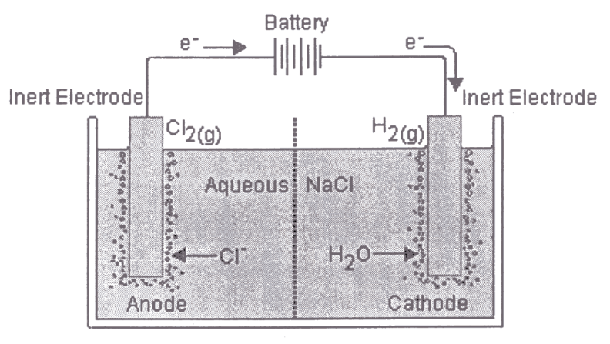  Using the information from the above diagram, indicate using equations ONE possible anode AND ONE possible cathode reaction that may occur at these electrodes.  - Describe how the nature of the electrode affects the electrolytic reaction.  - Sodium, iron and silver are all metals. Arrange them in order of increasing reactivity and justify your answer using the table of Standard Reduction Potentials. | 1  2  2

Question 19 continued…  - In her study of electrolytic cells, a student came across the following diagram.  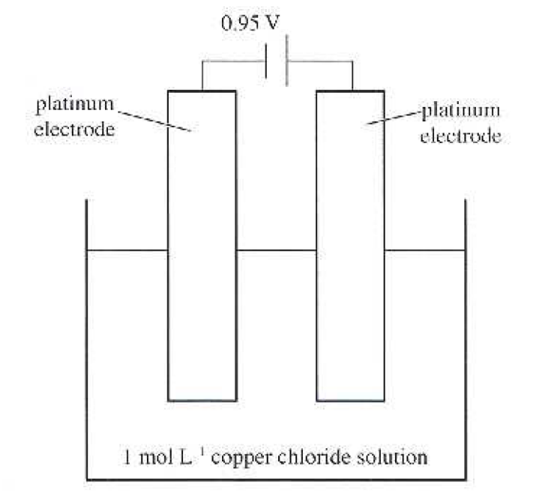  Based on this diagram, the student made the following predictions:  - The voltage was insufficient to form copper and chlorine by electrolysis of the solution  - The mass of the anode would increase as copper formed on it.  - A gas would form at the other electrode  - The pH of the electrolyte will not change.  Assess each of these predictions. Support your assessment with appropriate data and equations where possible to identify products. If the student’s prediction is incorrect, provide an alternate prediction. | 7

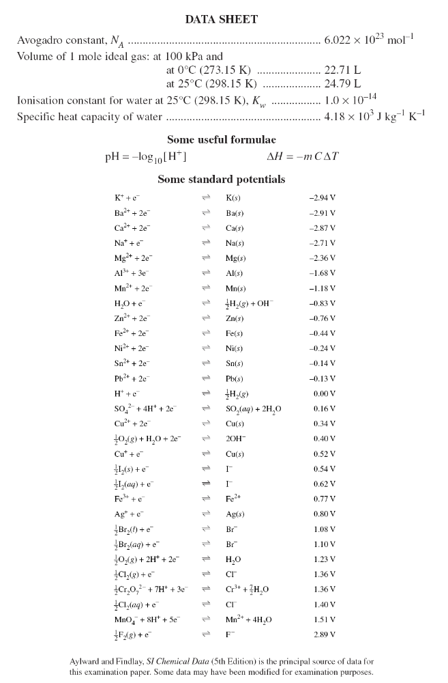

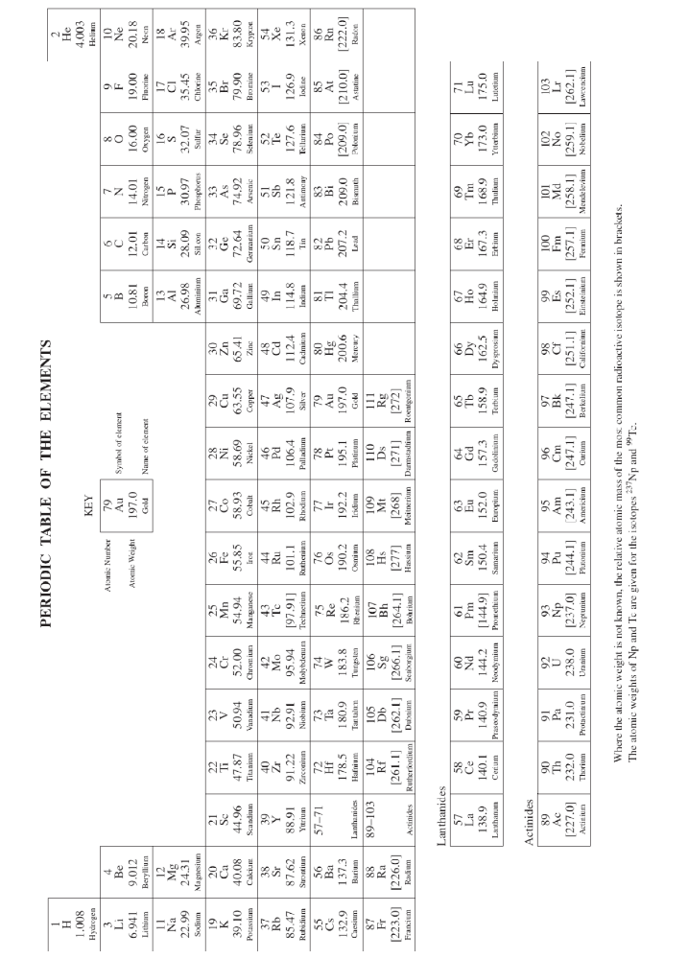
Stats

 | Questions | Total Marks | %
Knowledge and Understanding | Q1-10, 12-14, 18, 19b | 34 | 52
Skills in planning and conducting first-hand investigations and in communicating information based on these investigations | Q11, 17 | 10 | 15
Skills in scientific thinking, problem-solving and in communicating understanding and conclusions | 15,16,19ac | 21 | 32

 | Total | % | out of 17.5
Knowledge | 34 | 0.523077 | 9.153846154
Investigations | 10 | 0.153846 | 2.692307692
Problem Solving | 21 | 0.323077 | 5.653846154
 | 65 | 1 | 17.5

